1. REST API server

I used **json-server** (<https://github.com/typicode/json-server>) on my local machine with configuration file **db.json**

{

"bridge": {

"Vin": 110,

"R1": 300,

"R2": 200,

"R3": 700,

"R4": 1200

},

"results": [

]

}

Check connection using Chrome browser:

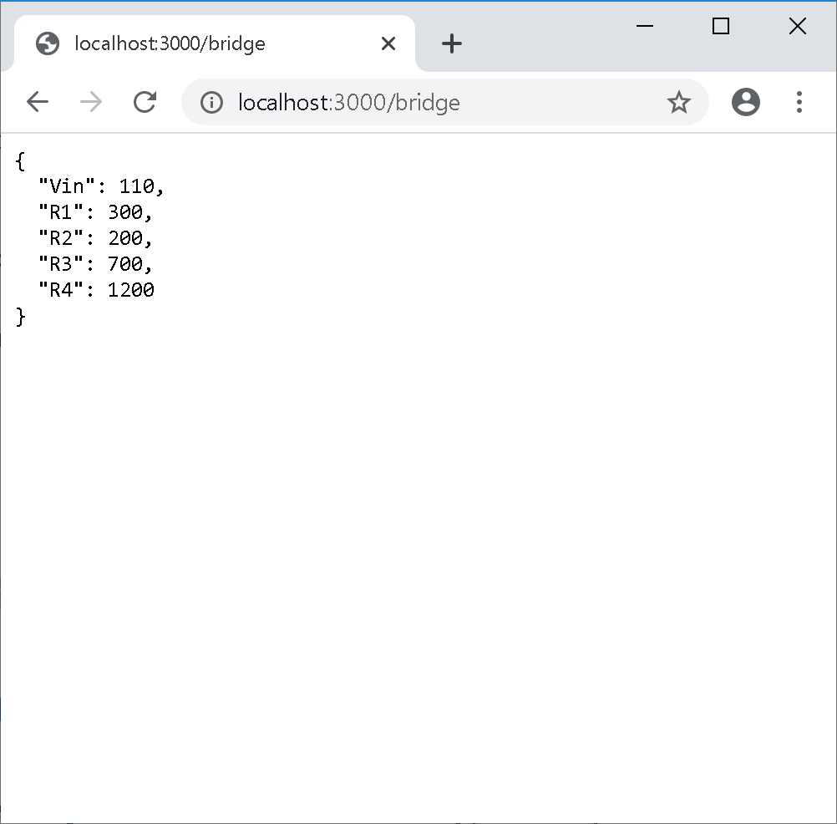

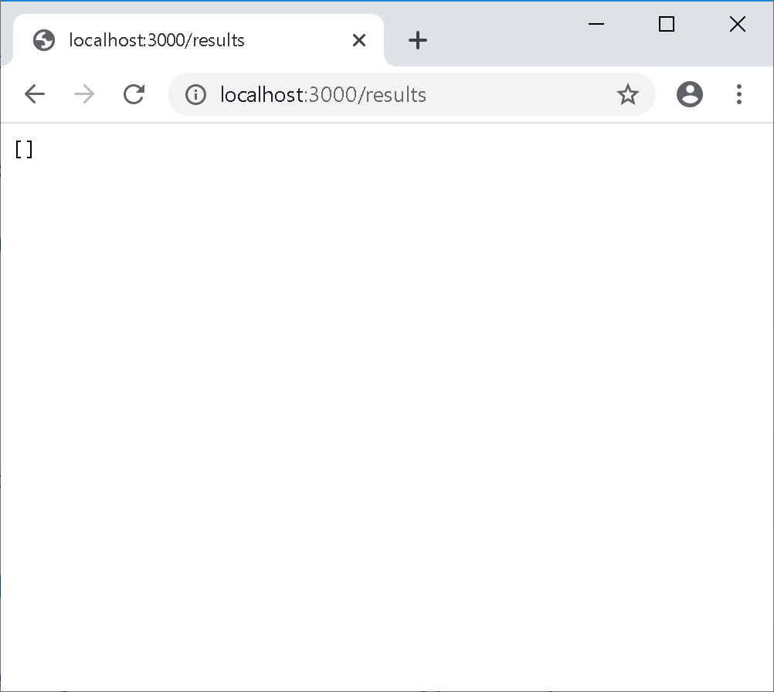

1. Labview REST API client

After **Get** button pressed

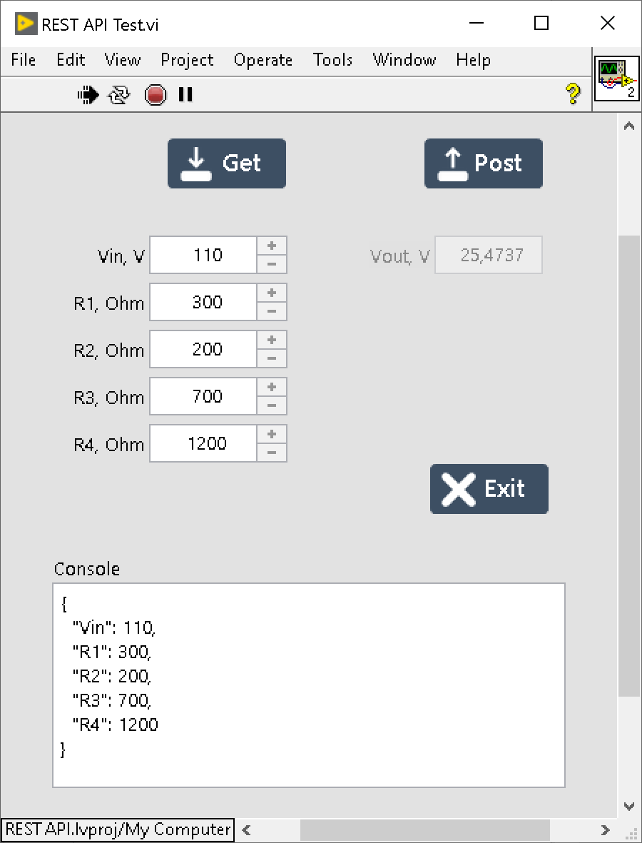

After **Post** button pressed

